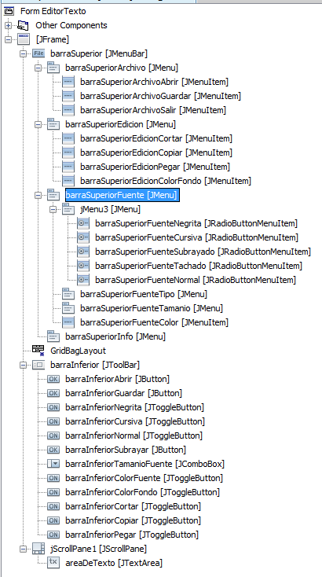

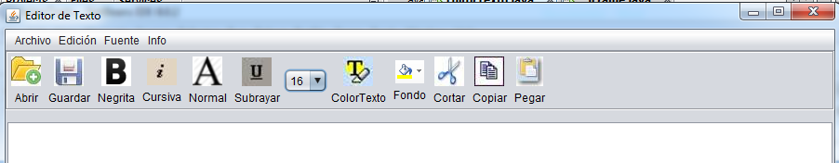

**Paquetes que utiliza el programa**

import java.awt.Color;

import java.awt.Font;

import java.awt.GraphicsEnvironment;

**import java.awt.datatransfer.Clipboard;**

import java.awt.datatransfer.DataFlavor;

import java.awt.datatransfer.StringSelection;

import java.awt.datatransfer.Transferable;

import java.awt.event.ActionEvent;

import java.awt.event.ActionListener;

**import java.awt.font.TextAttribute;**

import java.io.File;

import java.io.FileNotFoundException;

import java.io.FileReader;

import java.io.FileWriter;

import java.io.IOException;

import java.util.Map;

import java.util.logging.Level;

import java.util.logging.Logger;

import javax.swing.JColorChooser;

import javax.swing.JFileChooser;

import javax.swing.JLabel;

import javax.swing.JMenuItem;

import javax.swing.JOptionPane;

import javax.swing.filechooser.FileView;

**Declaración de variables**

private void initComponents() {

java.awt.**GridBagConstraints** gridBagConstraints;

barraInferior = new javax.swing.JToolBar();

**Programa MAIN**

public static void main(String args[]) {

/* Set the Nimbus look and feel */

//<editor-fold defaultstate="collapsed" desc=" Look and feel setting code (optional) ">

/* If Nimbus (introduced in Java SE 6) is not available, stay with the default look and feel.

* For details see http://download.oracle.com/javase/tutorial/uiswing/lookandfeel/plaf.html

*/

try {

for (javax.swing.UIManager.LookAndFeelInfo info : javax.swing.UIManager.getInstalledLookAndFeels()) {

if ("Nimbus".equals(info.getName())) {

javax.swing.UIManager.setLookAndFeel(info.getClassName());

break;

}

}

} catch (ClassNotFoundException ex) {

java.util.logging.Logger.getLogger(**~~EditorTexto~~JFRAME**.class.getName()).log(java.util.logging.Level.SEVERE, null, ex);

} catch (InstantiationException ex) {

java.util.logging.Logger.getLogger(EditorTexto.class.getName()).log(java.util.logging.Level.SEVERE, null, ex);

} catch (IllegalAccessException ex) {

java.util.logging.Logger.getLogger(EditorTexto.class.getName()).log(java.util.logging.Level.SEVERE, null, ex);

} catch (javax.swing.UnsupportedLookAndFeelException ex) {

java.util.logging.Logger.getLogger(EditorTexto.class.getName()).log(java.util.logging.Level.SEVERE, null, ex);

}

//</editor-fold>

/* Create and display the form */

java.awt.EventQueue.invokeLater(new Runnable() {

public void run() {

new EditorTexto().setVisible(true);

}

});

}//Fin MAIN